
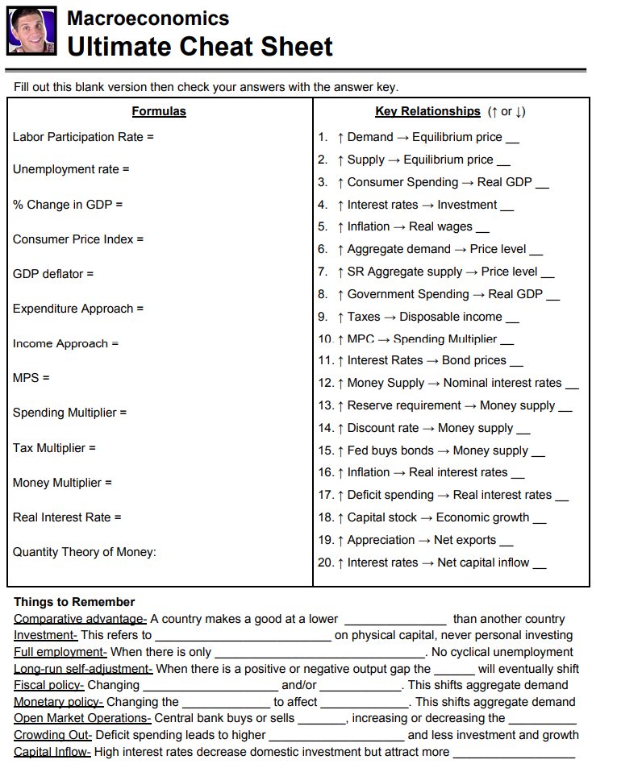
Capital Inflows
Money Supply
Interest Rates
Bonds
↓
↑
↑
↑
↑
↓
↓
↓
↓

↑
M=money supply
V =velocity of money
P= Price
Q = Quantity of goods (RGDP)

RRR = required reserve ratio
MV = PQ
1/RRR
RRR = required reserve ratio
-MPC/(1-MPC)
(negative and x MPC because not all of the tax money would be spent.)
1/(1-MPC) = 1/MPS
Marginal Propensity to Save
(how much you save of additional income)
↓
↑
↑
↓
↑
↓
↓
↑
↓
↑
Interest Rates
Money Supply
Tax
Government Spending
SRAS
structural and frictional unemployment
firm spending
OC = what you give up / what you gain
opportunity cost
Nominal Interest Rate - Inflation
wages + rent + interest + profit
(labor) (land) (capital) (enterprise)
C+I+G+(X-M)
[Nominal GDP /Real GDP] x 100
[MB_{New} /MB_{baseyear}] x 100
[GDP_{New} – GDP_{Old} / GDP_{Old}] x 100%
unemployed /
(employed + unemployed)
(employed + unemployed) / Working Age Population

